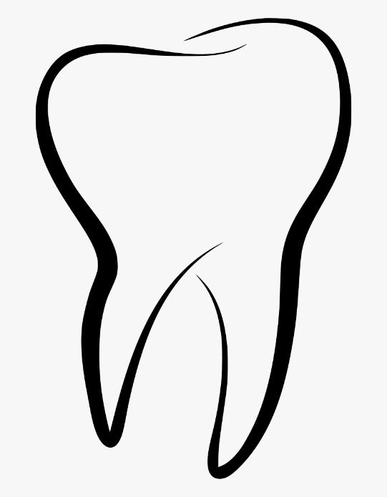

Newtown Family Dentistry

**Deidre M. Condon DMD, Garrett B. Golisano DDS, James R. Flynn DMD**

172 Mt. Pleasant Rd.

Newtown, CT

203-426-0045